Setting up S3
Step 1:
Look up S3 in the AWS Console
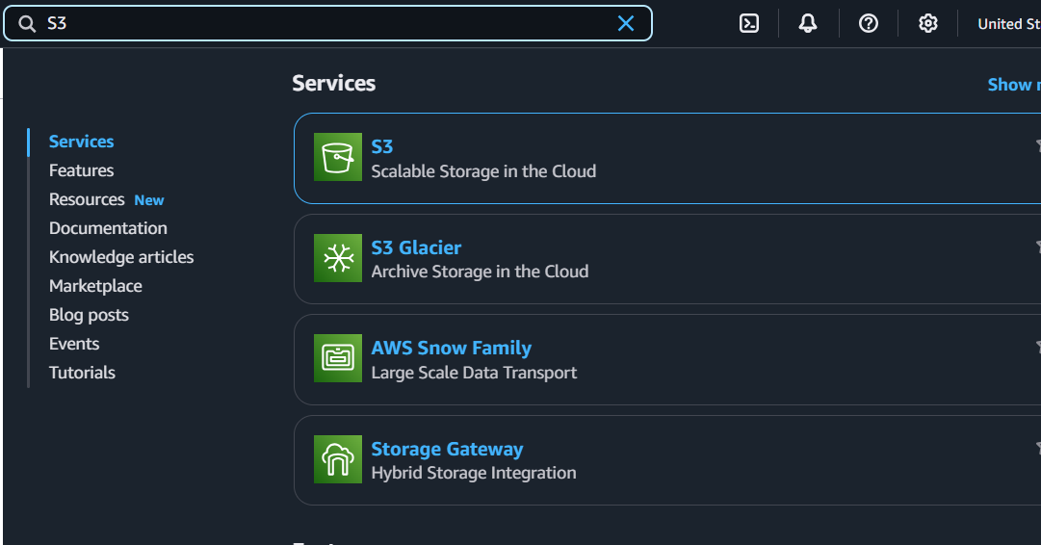
Step 2:
Click Create Bucket
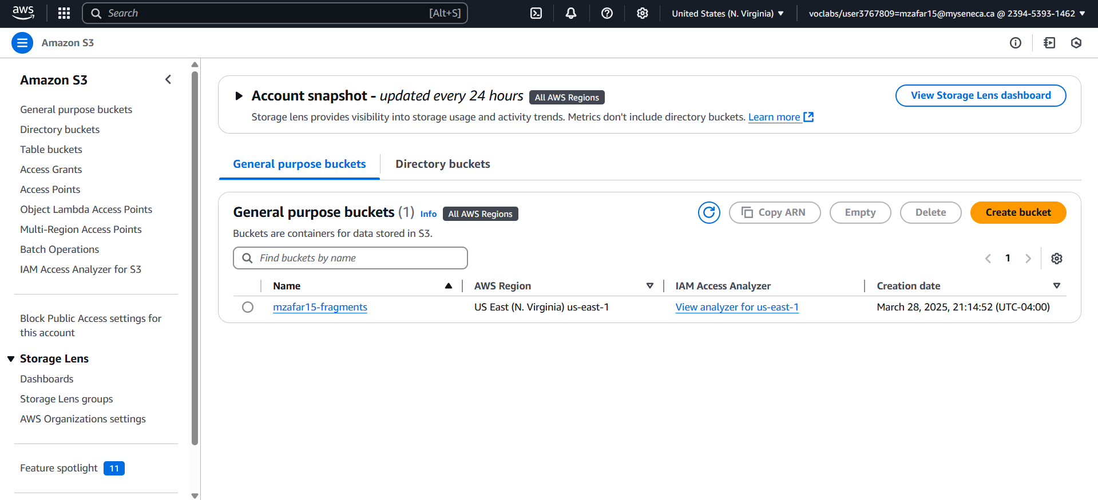
Step 3:
Give the Bucket Name
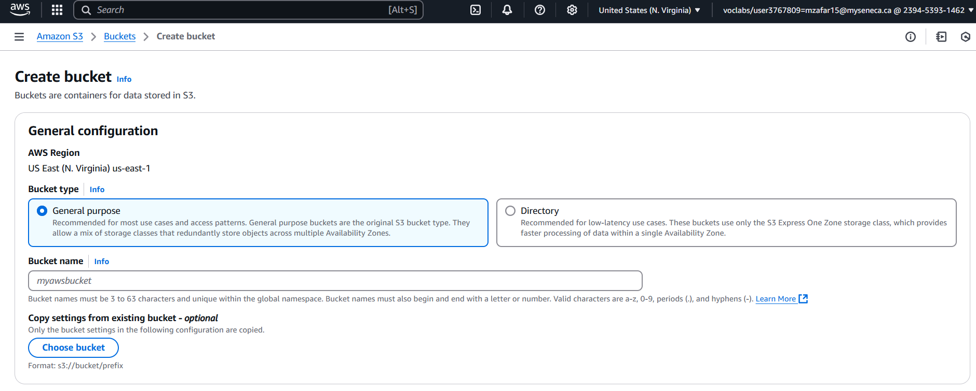
Step 4:
Set the Object Ownership
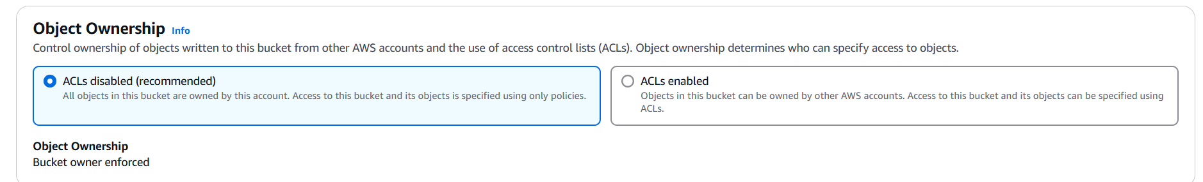
Step 5:
Block Public accessing for bucket
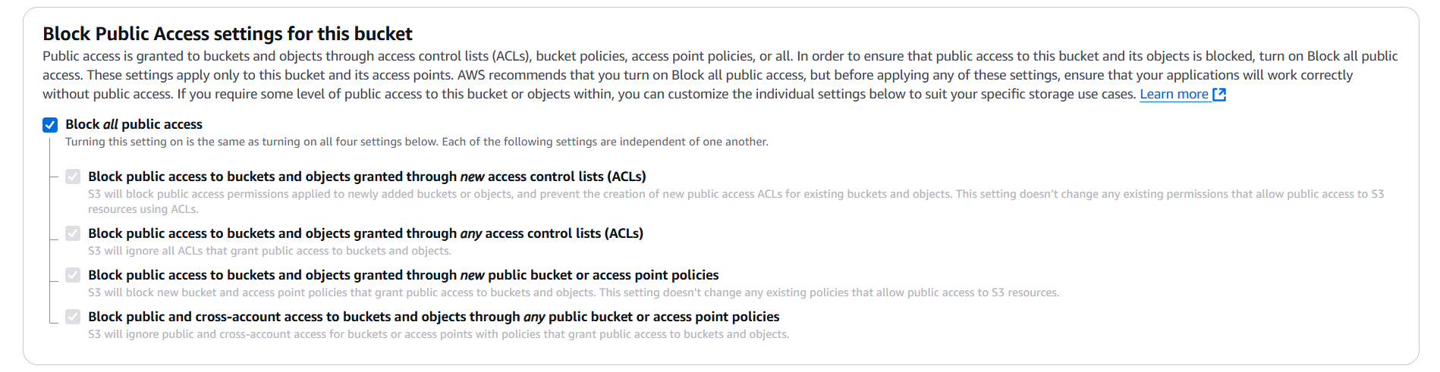
Step 6:
Disable Bucket Versioning (can enable if you want)
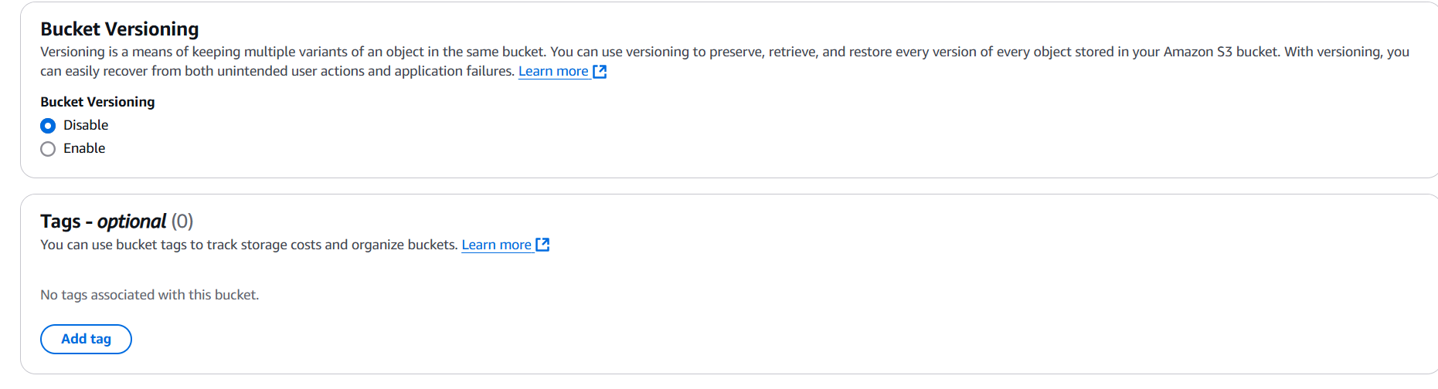
Optional Settings
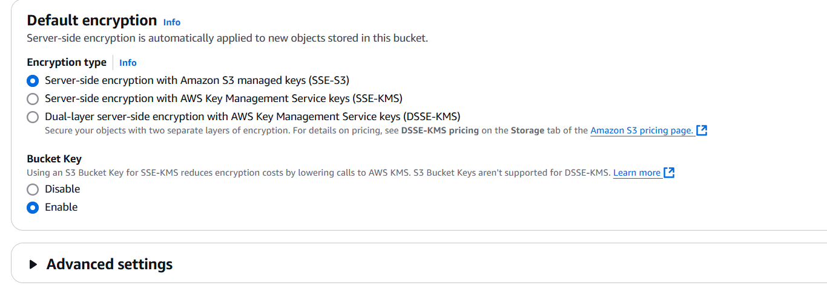
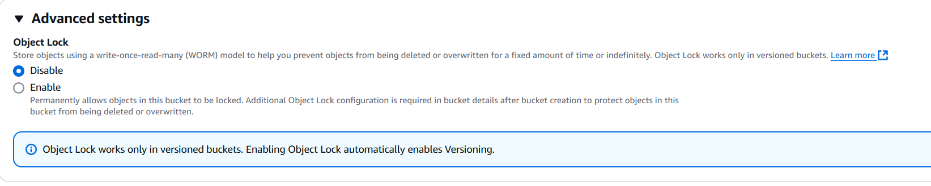
Step 7:
Click Create Bucket


Seeing the Bucket in AWS S3 CLI
